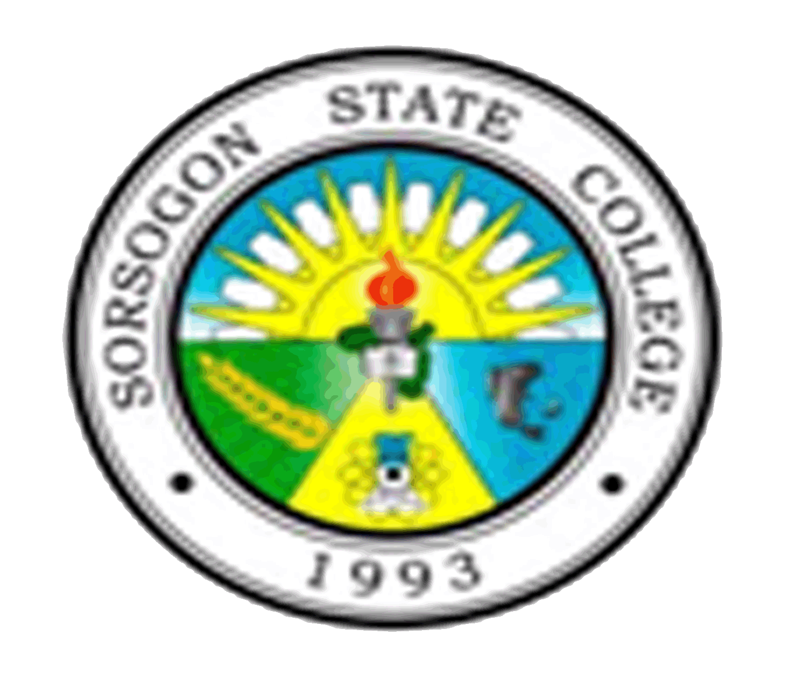
Republic of the Philippines
SORSOGON STATE COLLEGE
FUTURE EDUCATORS’ GUILD
Sorsogon City Campus
Sorsogon City

FEG OFFICERS
SY 2012-2013

President OLIVER GARBIN

Vice-President ARVIN EBIO

Secretary MABELLE EBRADA

Treasurer ROBIE BENZON

Auditor JAYSON REYES

Business Managers JAZER HAMOR
MARK RYAN LASTRILLA

P.I.O. RONALD ESTRABELA

REPRESENTATIVES

1st year DONNA MAE LAZO

2nd year JONALYN LELIS

3rd year NORMAN BONTIGAO

